**NIMANSA PUBLISHERS BOOK MANAGEMENT SYSTEM**

**NATIONAL INSITITUE OF BUSINESS MANAGEMENT**

**Diploma in Computer System and Design 19.1(Full time)**

**Supervisor Mr. Sujeewa Sampath**

**MANAGEMENT OF INFORMATION SYSTEM DEVISION,**

**NATIONAL INSITITUE OF BUSINESS MANAGEMENT**

**COLOMBO 7**

Submission date: 7/12/2020

# Declaration

We hereby declare that the Software project work entitled “Nimansa publishers book management system)” submitted to the National Institute of Business Management is an original work done by the members in our group, under the guidance of our Supervisor Mr. Sujeewa Sampath and this project work is submitted in the partial fulfillment of requirement for the awardiry of the diploma in system analysis and design. The results embodied in this report have not been submitted to any other University or Institute for the award of any degree or diploma.

……………………………. ……………………………

Date Supervisor Signature

# Preamble

**Abstract**

The Nimansa publishers Book Management is the book publisher company of Sri Lanka. It publish the books and sale the books yearly. They publish comic books and novels. They are the first publisher who publish comic books. But they don’t have an efficient book management system. The company still uses outdated methods of managing, storing and doing mathematical calculations of data. Still they use manual system for their works.

As a solution for this problem and due to request of the company we have been given an opportunity to propose and implement an effective book management system for the company .This software will assist the users to insert, update, and search and delete records.

So we believe that our software will increase the performance of the company and the issues faced by the company in managing their data.

Contents

Declaration

II

Preamble

III

Abstract

V

Acknowledgement

Chapter 1 - Introduction

1.1 Company Overview 6

1.2 Problem Definition 6

1.3 Proposed Solution 6

1.4 Requirements

* Funtional Requirements 7
* Non Funtional Requirements 7

Chapter 2- Analysis

2.1 Use Case Diagram of Existing System 8

2.2  Use Case Diagram of Proposed System 9

2.3 Class Diagram of Proposed System 10-11

2.4 Sequence Diagram of Proposed System 12-15

2.5 Entity Relationship Diagram of Proposed System 16

Chapter 3- Design

3.1 File Design 17-20

3.2 Interface Design 21-53

3.3 Error Messages 54-60

3.4 successful Messages 61-63

Chapter 4- Report Design 64-67

66Conclusion 68

References 69

**Acknowledgement**

First we would like to thank Mr. Sujeewa Sampath for the tremendous support and supervision provided to our team. Without his supervision we would not be able to successfully complete the project. We would thank for all of the lectures for giving their advices.

We are kindly thankful to the Nimansa Publishers manager and staff for guidance and support to us.

Finally it goes without mention how thankful we are for our families and loved once who providing with the good situation.

**Chapter 1 – Introduction**

**1.1 Company Overview**

The owner of Nimansa Publishers is Mr. Wasantha Kumara Paranavithana. It has been 12 years since the Nimansa Publishing Company started. They publish comic books. They are the first publisher who publish comic books.

After 5 years they also attended the BMICH book fair. From then until now, they participate annually. They have already published about 300 comic books. Now a day Nimansa Publishers are famous publishing company in the country.

**1.2 Problem Definition**

In the past Nimansa Publishers used a manually system. They ordered books and calculate invoice are all are doing manually. But now they are published lots of books and they want a computerized system.

They want to know how many orders we received, how many customers bought in their books, how many books that they sold and monthly income report.

**1.3 Proposed Solution**

According to in this problem we will create a software program. In this software we can see how many orders we received and how many books we have sold.

Another advantage is in this software we can see employee details and software shown yearly sales report. In this system user friendly and will help to make a decision easily.

**1.4 Requirements**

**Functional Requirements**

1. Ordering system
   * Create account
   * Manage account
   * Login in to the account
   * Received orders
   * Received conformation message of an email.
2. Item Management system
   * Add a new/update/delete order category
   * Add a new/update/delete orders
   * Update price for orders
   * Update additional information (description, Photo, etc.)
3. Generate reports
   * Generate monthly orders completed report
   * Generate monthly income report
   * Generate yearly sales report

**Non-functional Requirements**

* The software should be portable.
* Only admin will be able to change and look in to order table.
* User friendliness is one of the major benefits.
* As orders get completed and delayed by the recorded in the system backlog.
* To run the software, the pc will have to at least an i3 processor and 2 GB RAM and network connection.

**Chapter 2 – Analysis**

**2.1 Use Case Diagram Of Existing System**

** At the previous they did not have a computerized system.They had only manual system.

manager

Manager

user

Assistant

**2.2 Use Case Diagram Of Proposed System**

<<include>>

<<include>>

<<include>>

Assistant

<<include>>

<<extend>>

<<extend>>

<<extend>>

<<include>>

Manager

<<extend>>

<<extend>>

Manager

User

Assistant

**2.3 Class Diagram Of Proposed System**

* User roles have must be user login and user login have many user role and user role have one user login.
* User has many user roles and user role has many users.
* Invoice must be tack out customer and one invoice have one customer and one customer has one invoice.
* Book must be having book inventory and many books has one inventory one inventory has many books.
* One user and one user make many purchase orders.
* Book has many book supplier and book supplier has one book.
* Purchase order has one book and book has many purchase orders.
* Book supplier has many purchase order and purchase order has many book suppliers.
* User make many purchase orders and one purchase order has one user.

**2.4 Sequence Diagram Of Proposed System**

**SEQUENCE DIAGRAM OF USER LOGIN,RESET PASSWORD IN PROPOSED SYSTEM**

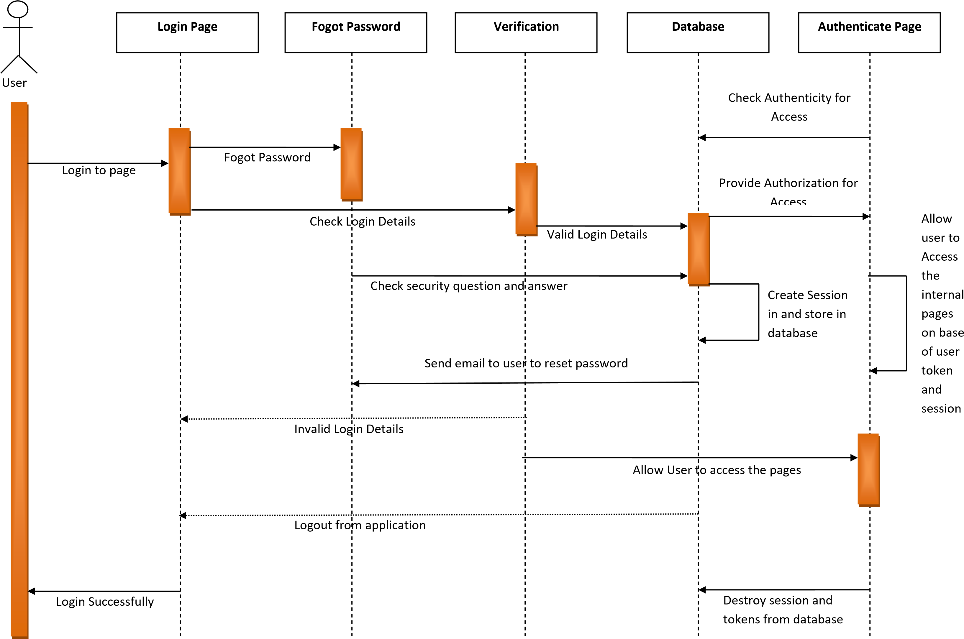

**SEQUENCE DIAGRAM OF SUPPLIER ADD/UPDATE/DELTE IN PROPOSED SYSTEM**



**Login Success**

**SUPPLIER**

**Management**

**Inventory**

**Management**



Login to page

Add/

Edit

supplier

User



Manage supplier

Save

supplier

List/Delete

supplier

**Manage Inventory Details**



Save

Inventory

Add/Edit

Inventory

List/Delete

Inventory

**SEQUENCE DIAGRAM OF CUSTOMER UPDATE/DELETE/ADD IN PROPOSED SYSTEM**



**Login Success**

**customer**

**Management**

**Inventory**

**Management**



Login to page

Add/

Edit

customer

User



Manage customer

Save

customer

List/Delete

customer

**Manage Inventory Details**



Save

Inventory

Add/Edit

Inventory

List/Delete

Inventory

**SEQUENCE DIAGRAM OF BOOK ADD/DELETE PROPOSED SYSTEM**



**Login Success**

**Book Store**

**Management**

**Inventory**

**Management**



Login to page

Add/

book

User



Manage book

Save/ Update

Book

List/Delete

Book

**Manage Inventory Details**



Save/Update

Inventory

Add/Edit

Inventory

List/Delete

Inventory

**2.5 Entity – Relationship Diagram**

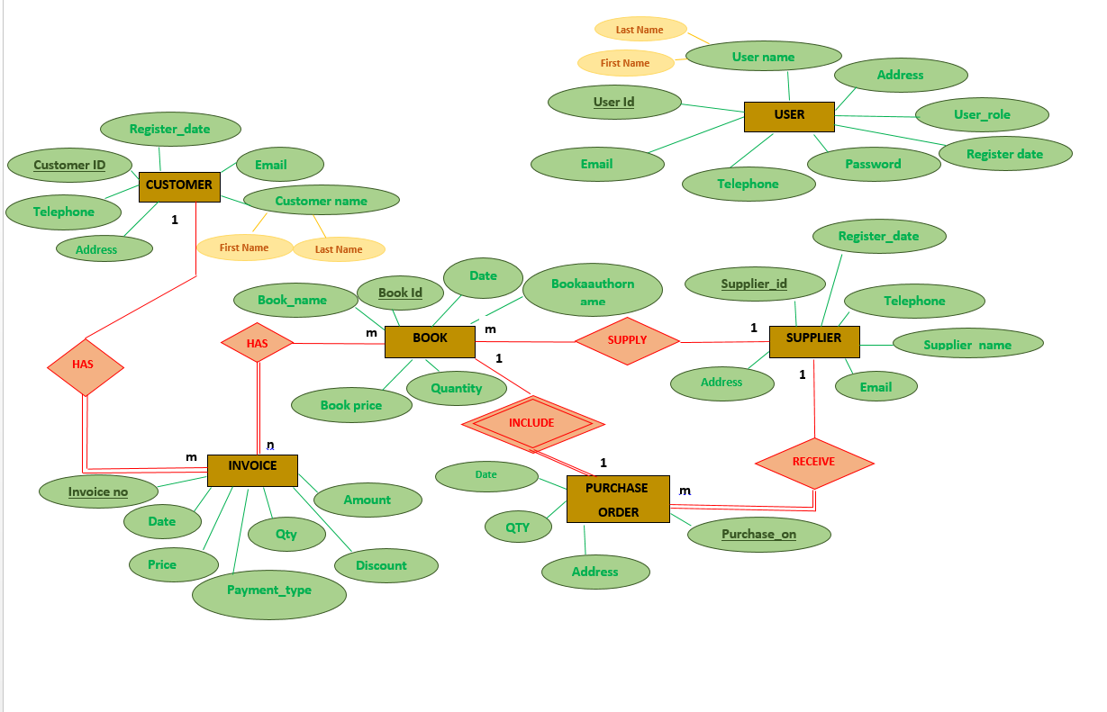

Assumptions:-

* All the customers has one phone number.
* All the customers must have email address.
* All the customers have only one address.
* All the suppliers have one phone number.
* All the invoice must have customers.
* All the invoice must have books.
* All the purchase order must have suppliers.
* One supplier can supply many books.
* One supplier can receive many purchase orders.
* One customer has many invoices and one invoice must have one customer.
* One book has many invoices and one invoice has many books.
* All the suppliers must have an email address.
* All the purchase order must have a book.
* One book can include one purchase order and one purchase order include one book.

**Chapter 3 –Design**

**3.1 File Design**

Table Number: 01

Table name: User_Registor

Primary key: user_id

User_Registor

|  |  |  |  |
| --- | --- | --- | --- |
| Column Name | Description | Data Type / Size | IsNul |
| user_Id (pk) | The user Id | Varchar (10) | 0 |
| First_name | The first name of the user | Varchar (100) | 0 |
| Last_name | The last name of the user | Varchar (100) | 0 |
| Address | The address of the user | Varchar (300) | 0 |
| User_role | The user role of the user | Varchar (25) | 0 |
| Password | The password of the user | Varchar (20) | 0 |
| Telephone | The telephone Number of the user | Int (11) | 0 |
| Email | The email address of the user | Varchar (100) | 0 |
| Register_date | The register date of the user | Date | 0 |

Table Number: 02

Table name: Customer

Primary key: Customer_Id

Customer

|  |  |  |  |
| --- | --- | --- | --- |
| Column Name | Description | Data Type / Size | IsNul |
| Customer_Id (pk) | The Customer Number | Varchar (10) | 0 |
| First_name | The first name of the customer | Varchar (20) | 0 |
| Last_name | The last name of the customer | Varchar (20) | 0 |
| Address | The address of the customer | Varchar (100) | 0 |
| Register_date | The register date of the customer | Date | 0 |
| telephone | The telephone number of the customer | Int (11) | 0 |
| Email | The Email Address of the customer | Varchar (500) | 0 |

Table Number: 03

Table name: Invoice

Primary key: Invoice_No

Foreign key\s: book_id

Invoice

|  |  |  |  |
| --- | --- | --- | --- |
| Column Name | Description | Data Type / Size | IsNul |
| Invoice_No (pk) | The invoice number | Varchar (10) | 0 |
| Date | The date of the invoice | Date | 0 |
| Payment_type | The payment type of the invoice | Varchar (50) | 0 |
| Customer_Id | The customer id | Varchar (10) | 0 |
| Book_id(fk) | The book id | Varchar (10) | 0 |
| Book_name | The name of the book | Varchar (50) | 0 |
| Price | The book price | Float (10,2) | 0 |
| Discount | The discount of the book | Float (10,2) | 0 |
| Amount | The book total amount | Float (10,2) | 0 |
| Quantity | The quantity of the books | Int | 0 |

Table Number: 04

Table name: Purchase_Order

Primary key: Purchase_on

Foreign key\s: Book_id, Supplier_Id

Purchase_Order

|  |  |  |  |
| --- | --- | --- | --- |
| Column Name | Description | Data Type / Size | IsNul |
| Purchase_on(pk) | The purchase order number | Varchar (10) | 0 |
| Supplier_Id (fk) | The supplier id | Varchar (10) | 0 |
| Book_id (fk) | The book id | Varchar (10) | 0 |
| Book_Name | The name of the book | Varchar (150) | 0 |
| Quantity | The quantity of the books | Int | 0 |
| Address | The suppliers’ address | Varchar (250) | 0 |
| date | The purchase order date | Date | 0 |

Table Number: 05

Table name: Login

Primary key: user_id

Login

|  |  |  |  |
| --- | --- | --- | --- |
| Column Name | Description | Data Type / Size | IsNul |
| User_id(pk) | The user id | Varchar (10) | 0 |
| User_role | The user role | Varchar (25) | 0 |
| password | The password of the user | Varchar (50) | 0 |

Table Number: 06

Table name: Book_supplier

Primary key: supplier_id

Book Supplier

|  |  |  |  |
| --- | --- | --- | --- |
| Column Name | Description | Data Type / Size | IsNul |
| Supplier_Id (pk) | The supplier id | Varchar (10) | 0 |
| Supplier_name | The name of the supplier | Varchar (50) | 0 |
| telephone | The suppliers’ telephone number | Int(11) | 0 |
| Email | The email of the book supplier | Varchar (500) | 0 |
| Address | The address of the book supplier | Varchar (100) | 0 |
| Register_date | The registered date of the supplier | Date | 0 |

Table Number: 07

Table name: Book_Registor

Primary key: Book_Id

Foreign key\s: supplier_id

Book_Registor

|  |  |  |  |
| --- | --- | --- | --- |
| Column Name | Description | Data Type / Size | IsNul |
| Book_Id (pk) | The book id | Varchar (10) | 0 |
| Book_name | The book name | Varchar (50) | 0 |
| Book_author_name | The book authors’ name | Varchar (70) | 0 |
| Book_Price | The price of the book | Float (10,2) | 0 |
| quantity | The quantity of the books | int | 0 |
| date | The date of the book registered | Date | 0 |
| Supplier_id(fk) | The supplier_id | Varchar (10) | 0 |

**3.2 Interface Design**

Interface number : 01

Interface name : Login Page

Description : This interface is main login. You have to type user name (Assistant or Manager) and password for login

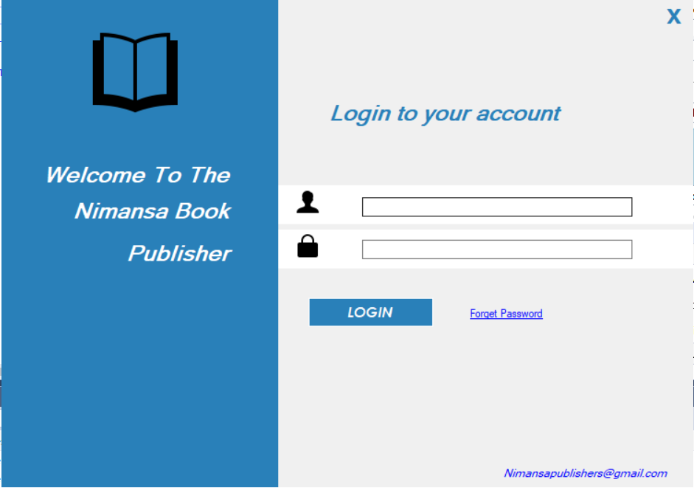

Interface number : 02

Interface name : Manager Dashboard

Description : If you are login as a manager you can see this interface.

Interface number : 03

Interface name : Customer Registration

Description : Manager can add new customers.The special feature is customer id is automatically genereted when the user open this interface..All the text boxes are validate . If user fill the fields and click the insert button data save automatically.

Interface number : 04

Interface name : Search Customer

Description : Manager can search customers ,using customers’ telephone number,

Data grid automatically shows the customer details.

Interface number : 05

Interface name : Update Customer

Description : Manager can update customer details. Firstly search the customer telephone number and click update button . Then update customer interface panel

Shown. After enter the update data fields, user can click update customer button and data update automatically.

Interface number : 06

Interface name : Delete customer

Description : Manager can delete customer.If the user(manager)wants to delete the customer data user must select the row and click the delete button.

Interface number : 07

Interface name : Book Registration

Description : Manager can register new books in this interface.

Interface number : 08

Interface name : Search Book

Description :

If the user has selected the book of the Manager dashboard, user will be able to view this interface. Search book also include the Book Registration interface is a combination of text boxes, labels, data grid and buttons .Text boxes, date and time have been validated according to the system requirement. User can search the data using book name. The entry will be displayed as always on the data grid.

Interface number : 09

Interface name : Delete Book

Description : Manager can delete the books. Firstly select the book id in data gridview and click delete button.

Interface number : 10

Interface name : Supplier Registration

Description : If the user has selected the supplier of the Manager dashboard, user will be able to view this interface.Supplier Register interface is a combination of text boxes, labels, data grid and buttons. The special feature in this interface is that supplier id is auto generated therefore the user don’t need to enter anything to supplier id text box since it is automatically calculated. Text boxes, date and time have been validated according to the system requirements. Insert supplier button add data into the data grid.

.

Interface number : 11

Interface name : Update Supplier

Description : Manager can update supplier details. Firstly search the supplier id and click update button . Then update supplier interface panel will Shown. After enter the update data fields, user can click update supplier button and data update automatically.

Interface number : 12

Interface name : Delete Supplier

Description : Manager can delete supplier .If the user(manager)wants to delete the supplier data user must select the row and click the delete button.

Interface number : 13

Interface name : Search Supplier

Description : Manager can search Supplier ,using Supplier telephone number ,Data grid automatically shows the Supplier details.

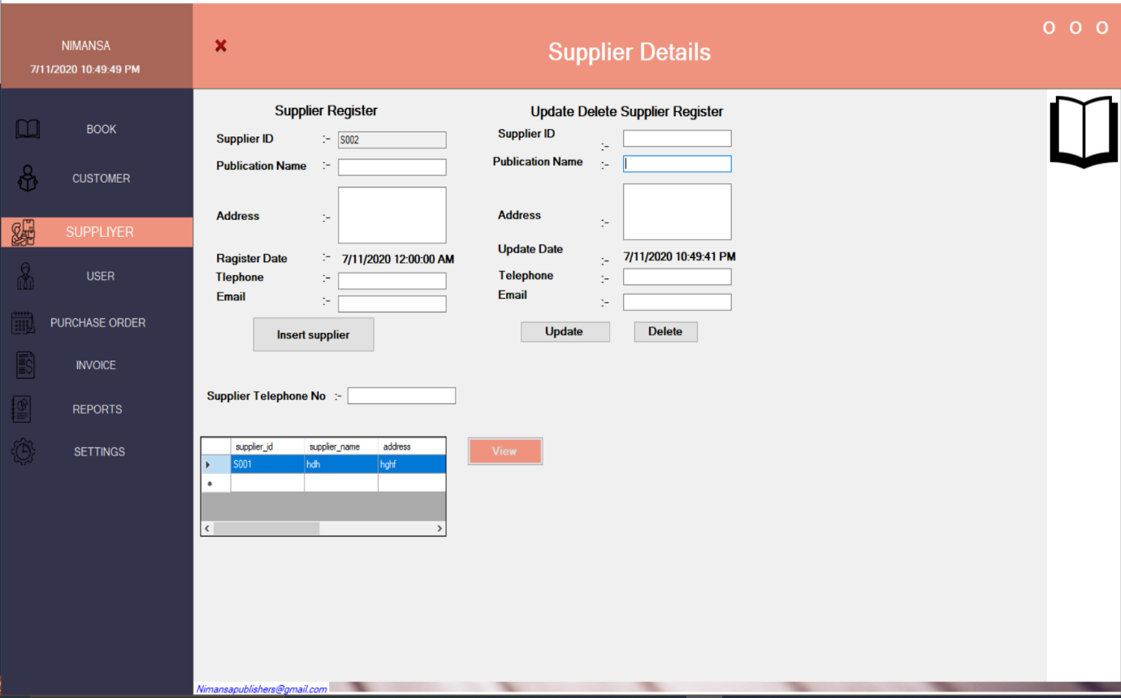

Interface number : 14

Interface name : Add User Interface

Description : If the user (manager) wants to add new user ,This interface shows the user registered details. The special feature in this interface is that user id is auto generated therefore the user don’t need to enter anything to user id text box since it is automatically calculated

Interface number : 15

Interface name : Delete User Interface

Description : Manager can delete user .If the user(manager)wants to delete the user data user must select the row and click the delete button.

Interface number : 16

Interface name : Purchase Order Interface

Description : If the user has selected the purchase order of the Manager dashboard, user will be able to view this interface. Purchase Order Interface also include combination of text boxes, labels, data grid and buttons. Text boxes, date and time have been validated according to the system requirement .Data grid display the tables user entered. The entry will be displayed as always on the data grid. Click Add Item button data add the data grid. If user click send order button order after order send the suppliers’ email. If user want to remove the entered the data, select the data grid entered row and click Remove Item button.

Interface number : 17

Interface name : Invoice Generate Interface

Description : The special feature in this interface is that invoice id is auto generated therefore the user don’t need to enter anything to invoice id text box since it is automatically calculated. Finally user can print invoice bill .If the user want to remove the data select the data row above the data grid and click the remove button.

Interface number : 18

Interface name : Setting

Description : This interface is very useful for user because user can get backup using vb script in this interface.

Interface number : 19

Interface name : Assistant Dashboard

Description : If you are login as an assistant you can see this interface.

Interface number : 20

Interface name : Add Customer Interface

Description : assistant can add new customers. The special feature is customer id is automatically genereted when the user open this interface. All the text boxes are validate . If user fill the fields and click the insert button data save automatically.

Interface number : 21

Interface name : Search_customer

Description : assistant can search customers ,using customers’ telephone number, Data grid automatically shows the customer details

Interface number : 22

Interface name : Update_customer interface

Description : assistant can update customer details. Firstly search the customer telephone number and click update button . Then update customer interface panel Shown. After enter the update data fields, user can click update customer button and data update automatically.

Interface number: 23

Interface name: Delete_customer interface

Description: assistant can delete customer.If the user(assistant)wants to delete the customer data user must select the row and click the delete button.

Interface number: 24

Interface name: Add Book Interface

Description: If the user has selected the book of the Assistant dashboard, user will be able to view this interface. Add book interface is a combination of text boxes, labels, data grid and buttons. The special feature in this interface is that book id is auto generated therefore the user don’t need to enter anything to book id text box since it is automatically calculated. Text boxes, date and time have been validated according to the system requirements .Data grid display the tables user entered. Insert Book button add data into the data grid.

Interface number: 25

Interface name: Search_Book Interface

Description: If the user has selected the book of the assistant dashboard, user will be able to view this interface. Search book also include the Add Book interface is a combination of text boxes, labels, data grid and buttons. Text boxes, date and time have been validated according to the system requirements .Data grid display the tables user entered. User can search the data using book name. The entry will be displayed as always on the data grid

Interface number: 26

Interface name: Delete Book Interface

Description: If the user has selected the book of the assistant dashboard, user will be able to view this interface. Delete book also include the Add Book interface is a combination of text boxes, labels, data grid and buttons. Text boxes, date and time have been validated according to the system requirements. Data grid display the tables user entered. User can search the data using book name. The entry will be displayed as always on the data grid. After the select the row and click the delete selected button data delete automatically.

Interface number: 27

Interface name: Add Supplier Interface

Description: assistant can add new supplier.The special feature is supplier id is automatically genereted when the user open this interface. All the text boxes are validate . If user fill the fields and click the insert button data save automatically.

Interface number: 28

Interface name: Update Supplier Interface

Description: assistant can update supplier details. Firstly search the supplier telephone number and click update button . Then update supplier interface panel shown. After enter the update data fields, user can click update supplier button and data update automatically.

Interface number: 29

Interface name: Delete Supplier Interface

Description: assistant can delete supplier.If the user(assistant)wants to delete the supplier data user must select the row and click the delete button.

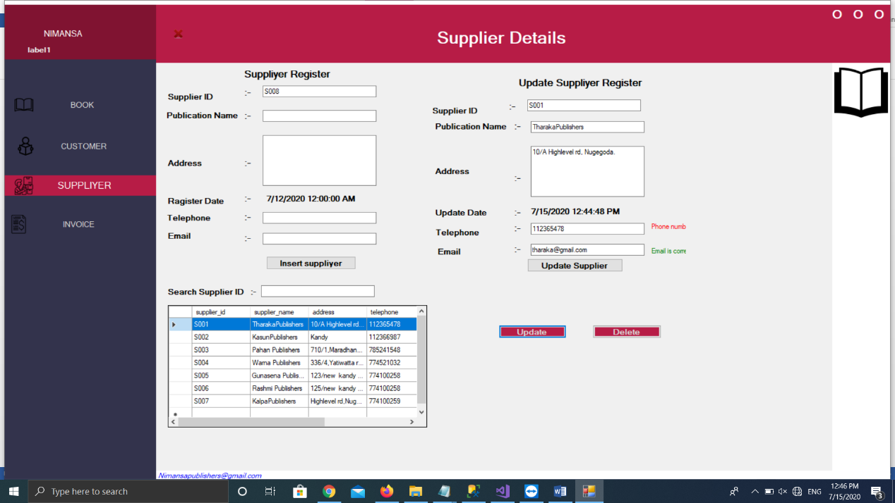

Interface number: 30

Interface name: search supplier Interface

Description: assistant can search supplier ,using supplier’ telephone number ,Data grid automatically shows the supplier details.

Interface number: 31

Interface name: Generate Invoice Interface

Description: : The special feature in this interface is that invoice id is auto generated therefore the user don’t need to enter anything to invoice id text box since it is automatically calculated. Finally user can print invoice bill .If the user want to remove the data select the data row above the data grid and click the remove button.

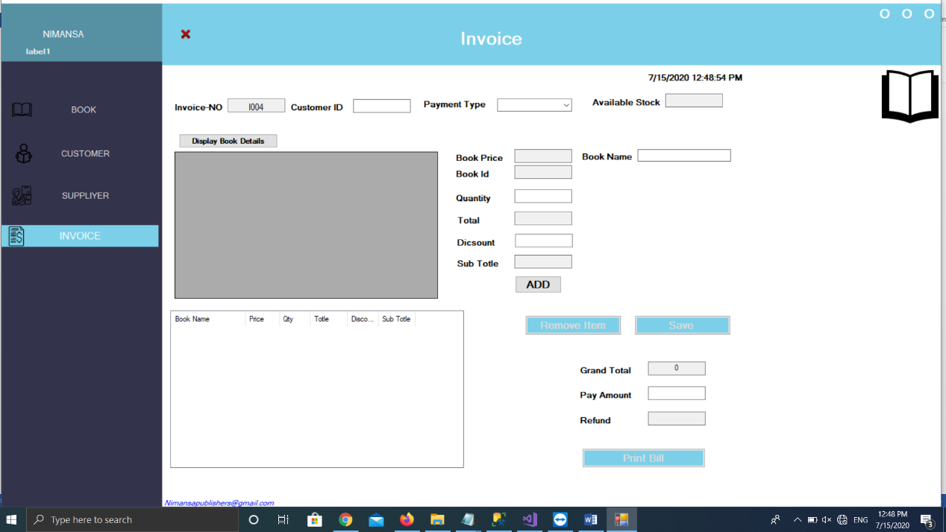

Interface number: 32

Interface name: Send Code Interface

Description: If the user forgot the password in login interface ,click the forgot password label, then this interface shows user for reset their password using code.

Interface number: 33

Interface name: Reset Password Interface

Description: If the user enter the email address in previous interface the code is send the entered email automatically . after the entered the code in text box, This interface automatically run and shown the user .Then user can set the new password.All the textboxes and buttons are validated.

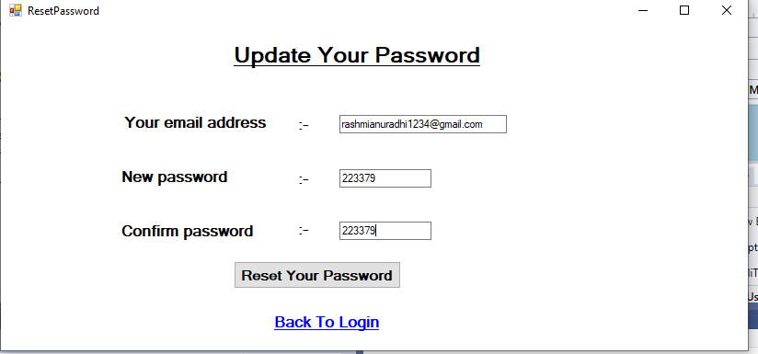

**3.3 Error Messages**

Message number : E01

Description : Login error.

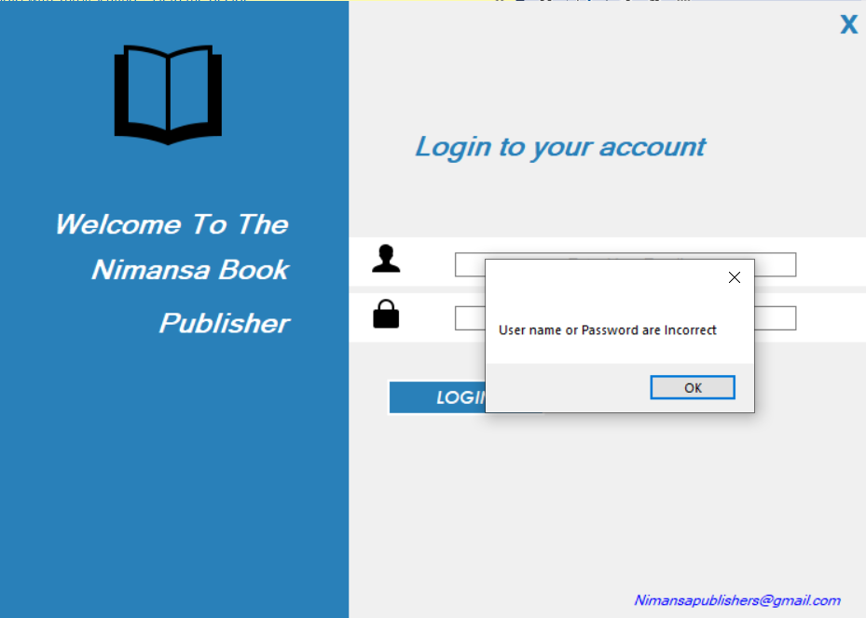

Message number : E02

Description :Enter The Letters only

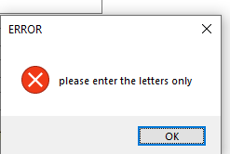

Message number : E03

Description :Enter The Numbers only

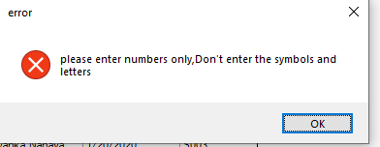

Message number : E04

Description :Please Fill The All Fields.Fiels cannot be empty.

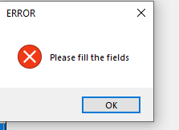

Message number : E05

Description :Price Cannot be Zero Values

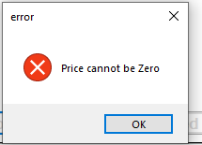

Message number : E06

Description :Password not matching in user form

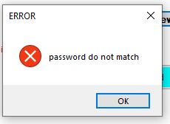

Message number : E07

Description :Quantity cannot be zero values

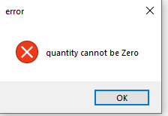

Message number : E08

Description :Enter the letters and numbers

Message number : E09

Message number : E10

Description :Enter the valid customer id

Message number : E11

Description :Enter the valid address

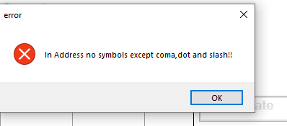

Message number : E12

Description :Enter the valid book name

Message number : E13

Description :This much quantity is not available

Message number : E14

Description :Enter the correct passowrd in reset password interface

Message number : E15

Description :Enter the invalid code

**3.4 Successful Messages**

Message number : S01

Description : Registration successfully.

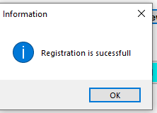

Message number : S02

Description : Data Delete successfully

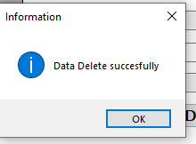

Message number : S03

Description : Record Inserted successfully

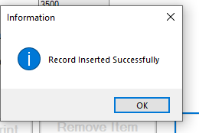

Message number : S04

Description : Data Updated successfully

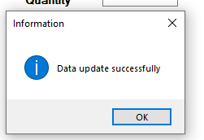

Message number : S05

Description : Backup data successfully.

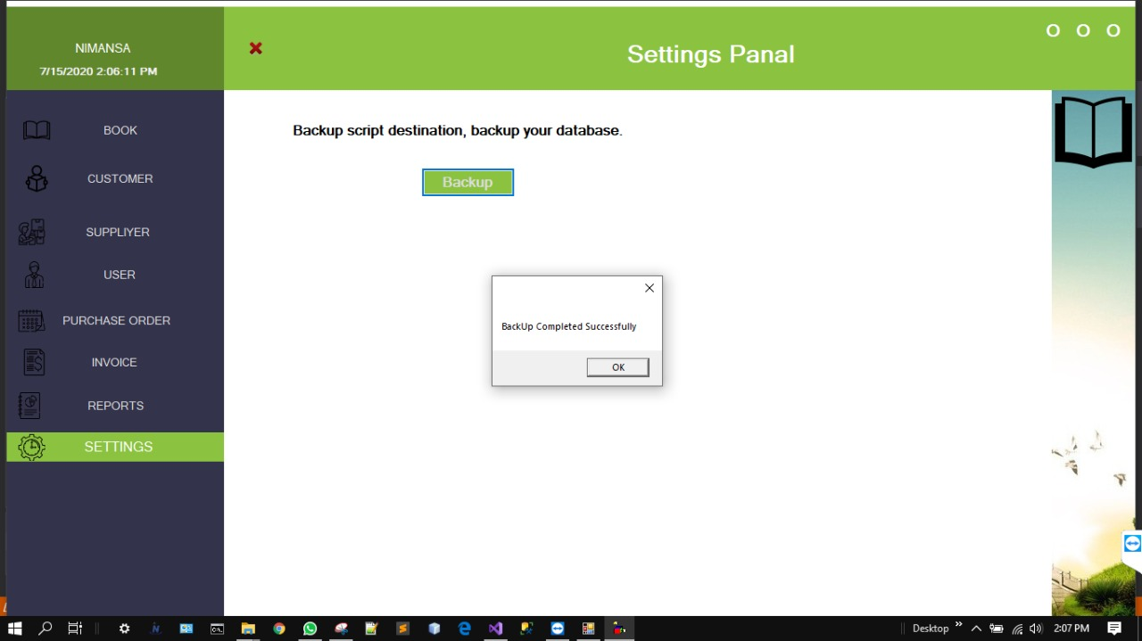

Message number : S06

Description : Send Code Successfully

**Chapter 4 –Report Design**

Report number : 01

Report name: Report main panel

Description: This report interface helps the user for see the reports.

Report number : 02

Report name : Invoice Report

Description : Manager can see our sales details in this report.

Report number : 03

Report name : Supplier Report

Description :Manager can see supplier details in this report

Report number : 04

Report name : Purchase_Order Report

Description :Manager can see supplier details in this report

**Conclusion**

The owner of Nimansa Publishers is Mr. Wasantha Kumara Paranavithana. It has been 12 years since the Nimansa Publishing Company started. They publish comic books. They are the first publisher who publish comic books.

After 5 years they also attended the BMICH book fair. From then until now, they participate annually. They have already published about 300 comic books. Now a day Nimansa Publishers are famous publishing company in the country.

In the past Nimansa Publishers used a manually system. They ordered books and calculate invoice are all are doing manually. But now they are published lots of books and they want a computerized system. This is big effect for the company to face the industry.

They want to know how many orders we received, how many customers bought in their books, how many books that they sold and monthly income report.

So in this problem we will create a software program. In this software we can see how many orders we received and how many books we have sold.

Another advantage is in this software we can see employee details and software shown yearly sales report.

**References**

API, s. and Killer, S. (2020). *Send message on WhatsApp number using WhatsApp API*. [Online] Stack Overflow. Available at: https://stackoverflow.com/questions/49430537/send-message-on-whatsapp-number-using-whatsapp-api.

Google Developers. (2020). *. NET Quick start | Gmail API | Google Developers*. [Online] Available at:

https://developers.google.com/gmail/api/quickstart/dotnet.

GitHub. (2020). *dennismagno/metro framework-modern-ui*. [Online] Available at: https://github.com/dennismagno/metroframework-modern-ui

Beautiful, H., Gray, C. and Gates, B. (2020). *How to make window forms look More Beautiful*. [Online] Stack Overflow. Available at: https://stackoverflow.com/questions/5013485/how-to-make-window-forms-look-more-beautiful

[Closed], w. and Johnson, T. (2020). *What optimizations can I do to run C# program faster?* [Online] Stack Overflow. Available at: https://stackoverflow.com/questions/11106525/what-optimizations-can-i-do-to-run-c-sharp-program-faster